

Test Automation

Experiment 6

Submitted by : Submitted to :

Akhand Pratap Singh Mr. Alind

**Step 1**: Activate environment:



**Step 2**: Create a project

# Command :- scrapy startproject fillform

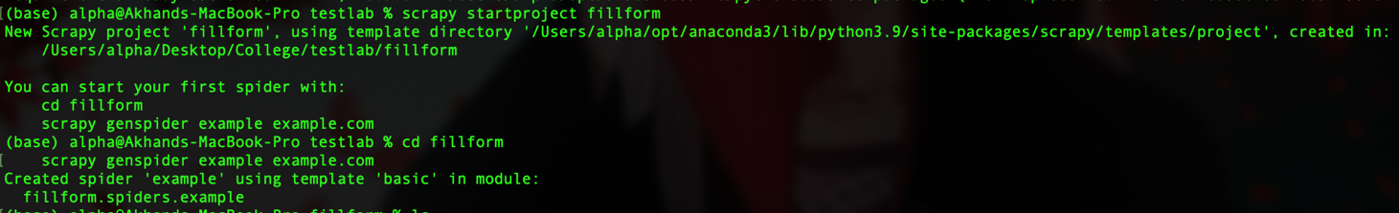

**Step 3**: RUN Command

scrapy genspider example example.com

**Step 4**: Write required code for Scraping Images through scrapy 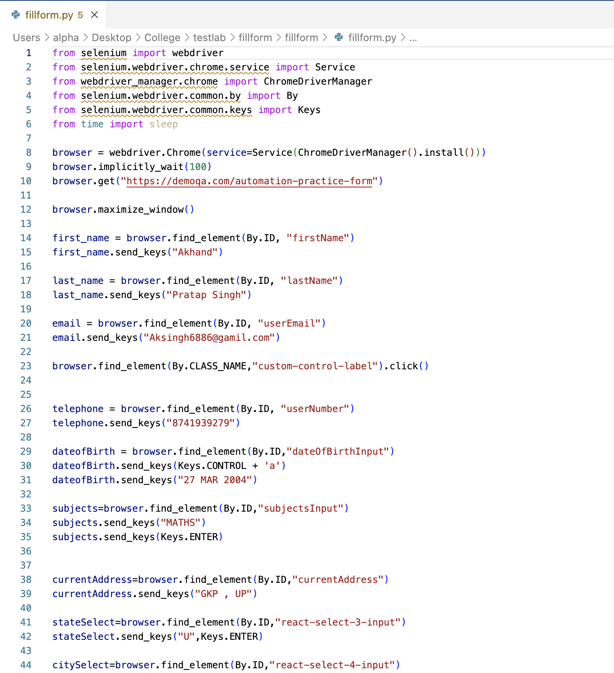

**Step 5**: Run the script

Command : -- python fillform.py

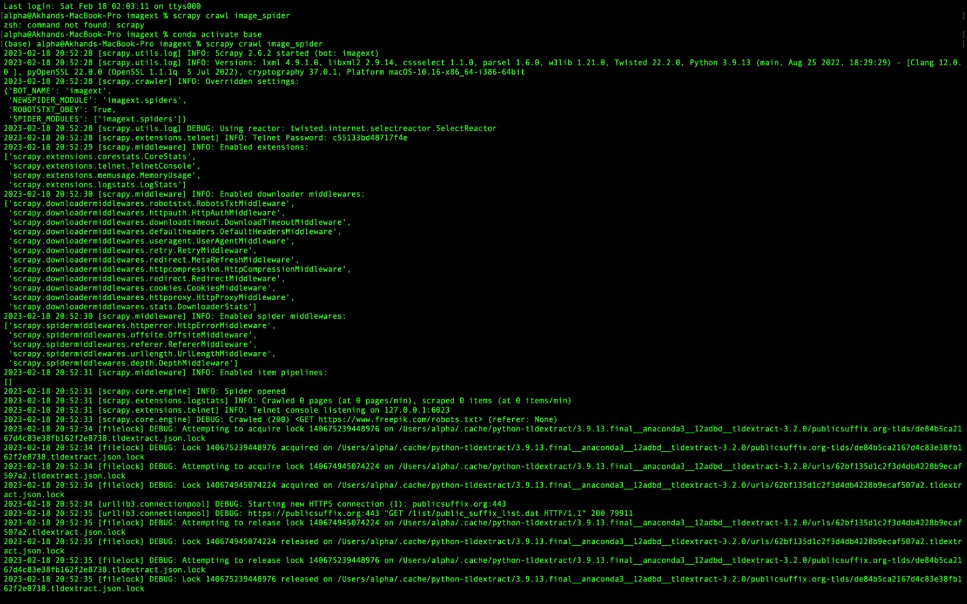

**Output Screenshot:**

